**Findings and Actionable Recommendations**

**#1: Visibility of System Status**

**Positive Findings:**

* In case of internet connectivity issues, the app displays an appropriate message regarding network failure to keep the user informed.
* The color text displayed on hover is helpful for color-blind users.

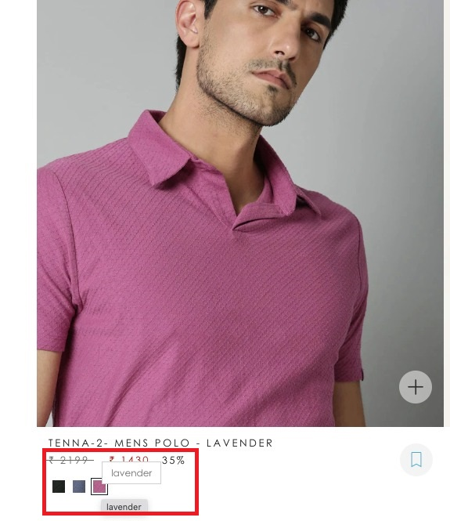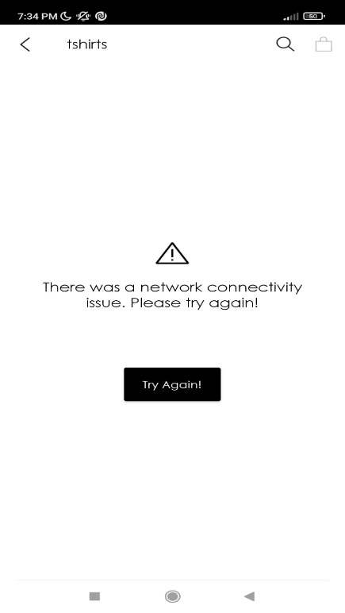

**Negative Findings & Possible Improvements:**

* A hyperlink enables the user to be notified via email if a particular size is not available. However, on hover, this link appears to be like any other selectable text on a webpage resulting in incorrect feedback to the user.

**Recommendation:** A standard hand pointer and underlined text on hover is a simple and clean solution to provide appropriate feedback.

* When accessing the ‘Size Chart’ the mobile app shows a blank screen for a few seconds before the chart is loaded.

**Recommendation:** A basic circular progress bar informs the user that the chart is loading and prevents any unwanted actions on his part.

**#2: Match between System and real world**

**Positive Findings:**

* The mobile app does a good job of making things intuitive and easily discoverable for the users using real-world icons like shopping bag for cart.

**Negative Findings & Possible Improvements:**

* The ‘Store Locator’ section of the app displays a jargonic error message when there is a connectivity issue.

**Recommendation:** Exception handling could be improved to display a more user-understandable error message like the one highlighted in Heuristic 1.

* The use of the ‘Rare Rabbit’ icon to go to the Home Screen in the mobile app is ambiguous as it may be confused for something else (like an About Us page).

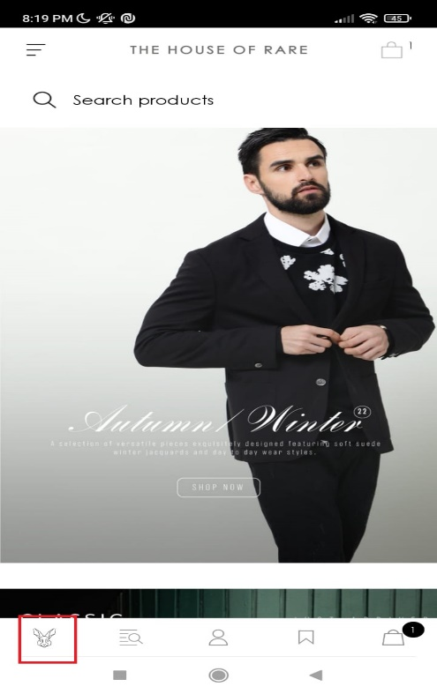

**Recommendation:** A simple and well-understood icon like the ‘Home Icon’ aligns well with the mental model of the user.

**#3: User control and freedom**

**Positive Findings:**

* --Need to Identify--

**Negative Findings & Possible Improvements:**

* Separate web pages for men’s and women’s clothing deny the user the freedom to shop for multiple people together.



**Recommendation:** This may be a business constraint but if not, then integrating the two websites allows greater freedom and a better user experience.

* Once added to the cart, the website does not give the option to change the size and color of the product. The user must remove the product from the cart, select his new preference and add it again.

**Recommendation:** The option to edit the size and color of the apparel can be enabled in the cart, as seen in other clothing brand websites.

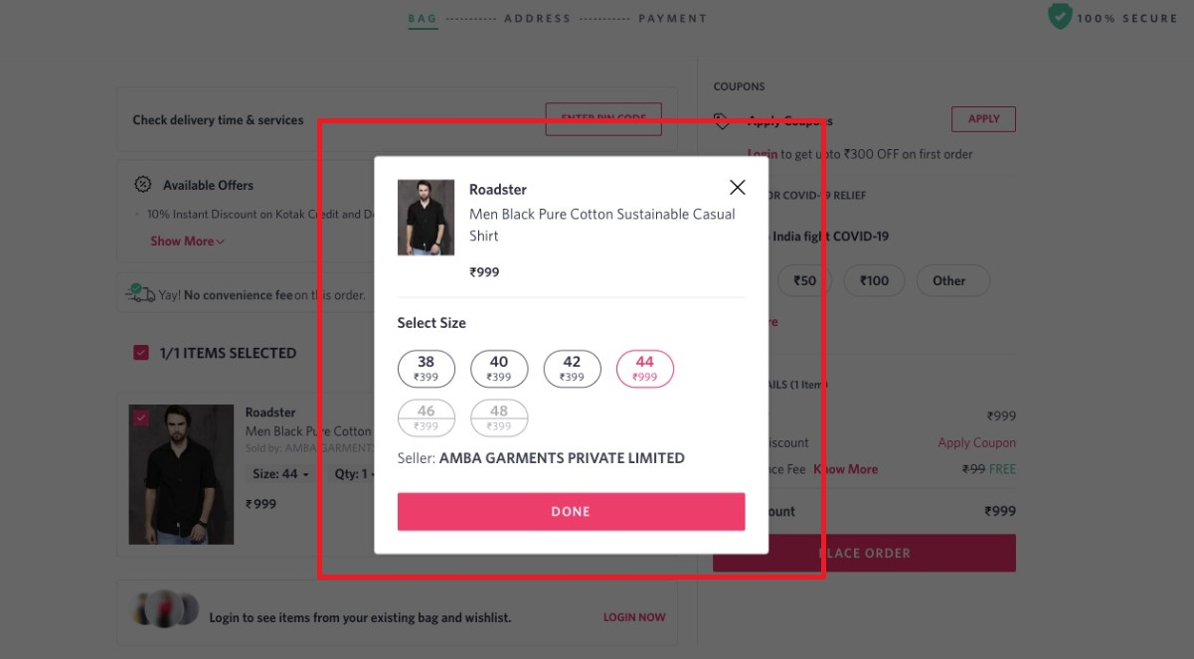

**#4: Consistency and Standards**

**Positive Findings:**

* 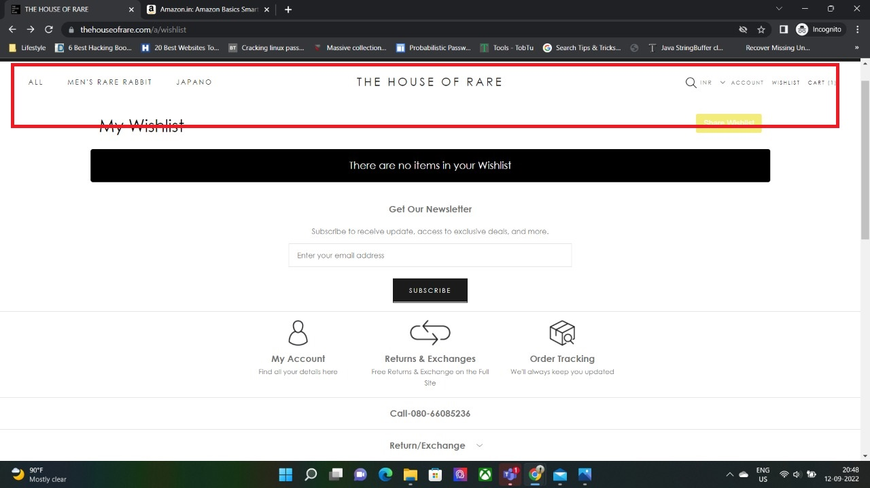The website header is consistent across all the pages and allows the user to navigate easily.
* Graphical user interface, website

  Description automatically generatedThe layout used for sorting and filtering apparel conforms to the standards established for e-Commerce platforms.

**Negative Findings & Possible Improvements:**

* The mobile app displays the ‘Cart Icon’ at multiple places on the same screen which is inconsistent with the layout and unnecessary.

**Recommendation:** Since the bottom navigation bar remains constant across all screens, the cart icon can be displayed there and removed from the title bar.

* When sorting the products in the mobile app, a Toast is displayed which is inconsistent and cryptic in its language.

**Recommendation:** The toast itself doesn’t seem necessary since the sorting menu already mentions the order of sorting. However, if it must be displayed, then the language must be complete.